**Home365 - How to connect to OpenVPN**

1. Login to - <https://openvpn.home365.co/> & put your credentials

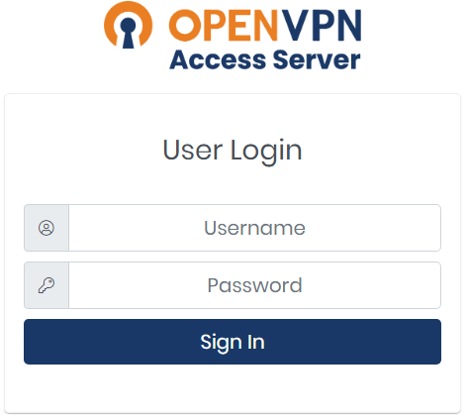

1. Scan the barcode with your phone (install Google authenticator or Authy)

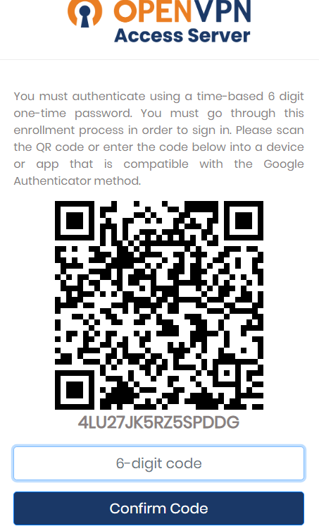

1. Download & install – recommended for your device -

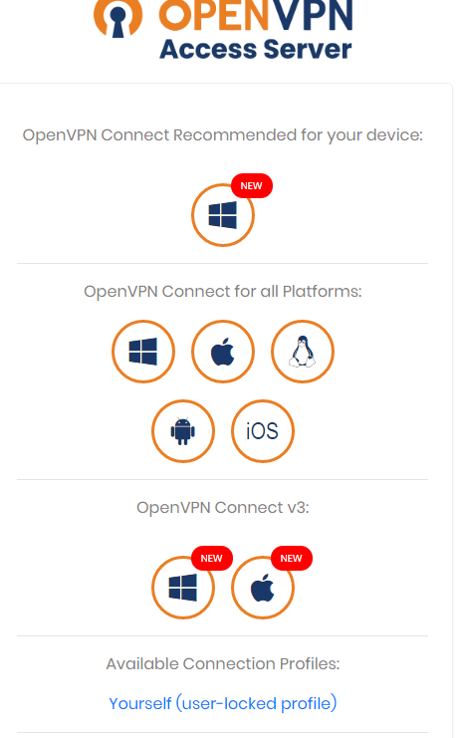

1. Open the client (from the bottom right side) and connect

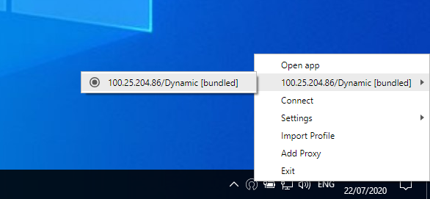

1. Put your credentials & token

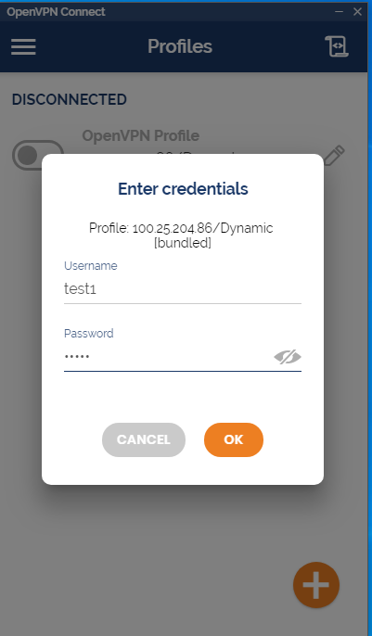

1. You are in

